IASTSS(65)
To open Data Sources (ODBC), click Start, click Control Panel, and then click
Windows XP : Performance and Maintenance.
Windows 7: System and Security
Click Administrative Tools, and then double-click Data Sources (ODBC).
If you are running a 64-bit operating system, and you would like to set up a 32-bit ODBC datasource, there is a different location from which the Data Sources control panel must be launched. Here is an example of the location on a Windows Vista 64-bit machine:
C:\Windows\SysWOW64\odbcad32.exe
C:\WINDOWS\SYSTEM subdirectory for the file ODBCAD.EXE (the 16-bit ODBC driver manager)
or the C:\WINDOWS\SYSTEM32 subdirectory for ODBCAD32.EXE (32-bit version).

Configure the file with the ODBC Data Source Administrator.

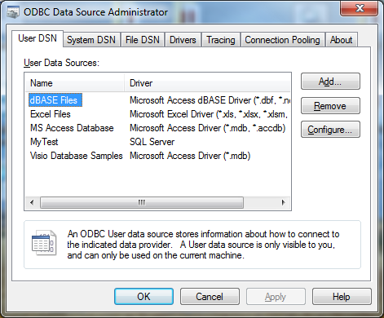

On the File DSN tab, click Add.

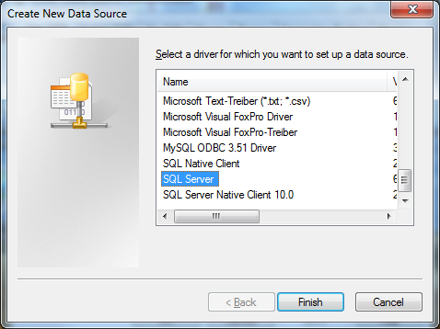

In the Create New Data Source dialog box, select SQL Server, and then click Finish

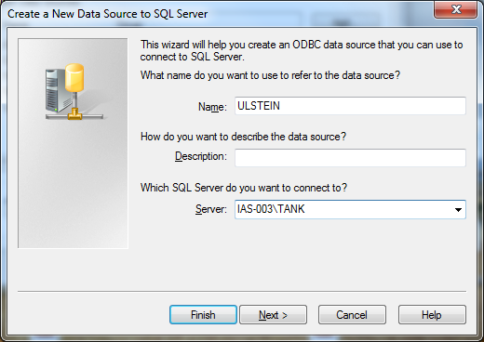

Next
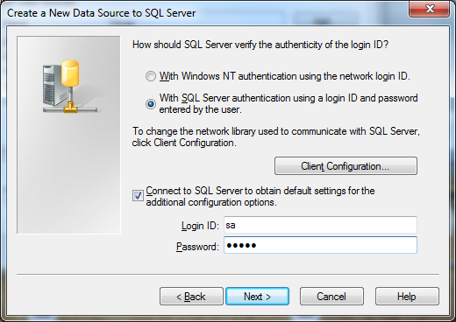
Next
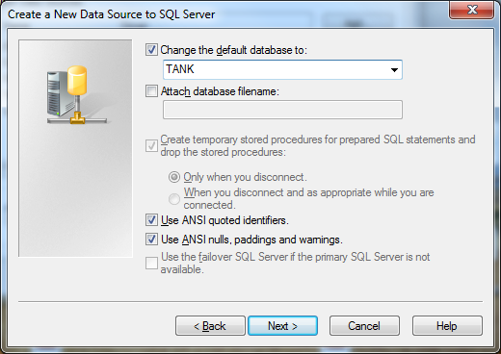
Next
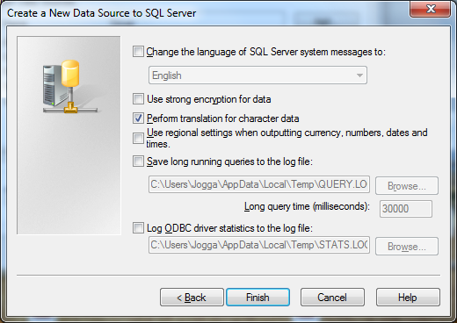
Finish
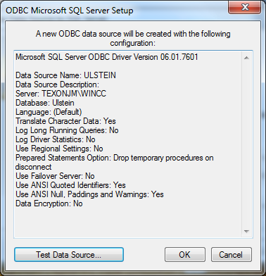
Test Data Source
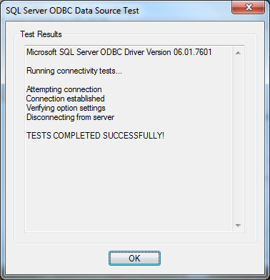

The configuration data selected by Ulstein to Open this Data Sources must be edited into LOADSMASTER/LEVELMASTER file ‘IASTSSini.txt’. You find this file on the directory
C:\Program Files (x86)\Kockum Sonics\KSL450
Edit as below:
# ODBC SQL Server Data Source,
"Connection","ULSTEIN"
Change the name of the User DSN
# User,
"UserID","sa"
Change the name of the user
# Password,
"Password","tyfon"
Change the password of the user
# SQL statement,
"LCS","SELECT TankNo, TAG, TagDescription, Unit, _Value FROM IASTSS_LCS ORDER BY TankNo, TAG"
TankNo, TAG, TagDescription, Unit and _Value according to the Column Names in the
Ulstein description of the IASTSS_LCS table
IASTSS_LCS is the database table according to the Table Name in the Ulstein specification for input to LCS
"IASTSS","LCS_IASTSS"
LCS_IASTSS is the database table according to the Table Name in the Ulstein specification
for output to IASTSS

When the communication between Ulstein and LOADMASTER has been verified, then our file ‘IASTSSini.txt’ must be sent to Kockum Sonics for backup.

